
Date | 30 September 2026
Team ID | SWTID-2026-3972
Project Name | Import Data using Transform Maps (Spreadsheet)
Team Leader | Kartheeswaran M
Team Member | Karuppasamy A
 | Mari Muthu G
 | Irfan U
Maximum Marks | 5 Marks

Project Title:
Import Data using Transform Maps

4. Project Planning Phase

The project execution is planned across several key steps to ensure a smooth implementation:

Step 1: Prepare the sample dataset in an Excel format.
Step 2: Create the target custom table (Employee Test) with appropriate String fields via the Tables module.
Step 3: Use the 'Load Data' module to create the Import Set table and upload the Excel file.
Step 4: Define the Transform Map, auto-map the matching fields, and execute the initial data transform.
Step 5: Validate the imported data in the target table.
Step 6: Configure 'Coalesce' on the Employee ID field within the Transform Map to handle updates.
Step 7: Re-import updated data to verify that existing records are updated and duplicates are ignored.
Step 8: Create custom reports based on the imported data and add them to a centralized dashboard.

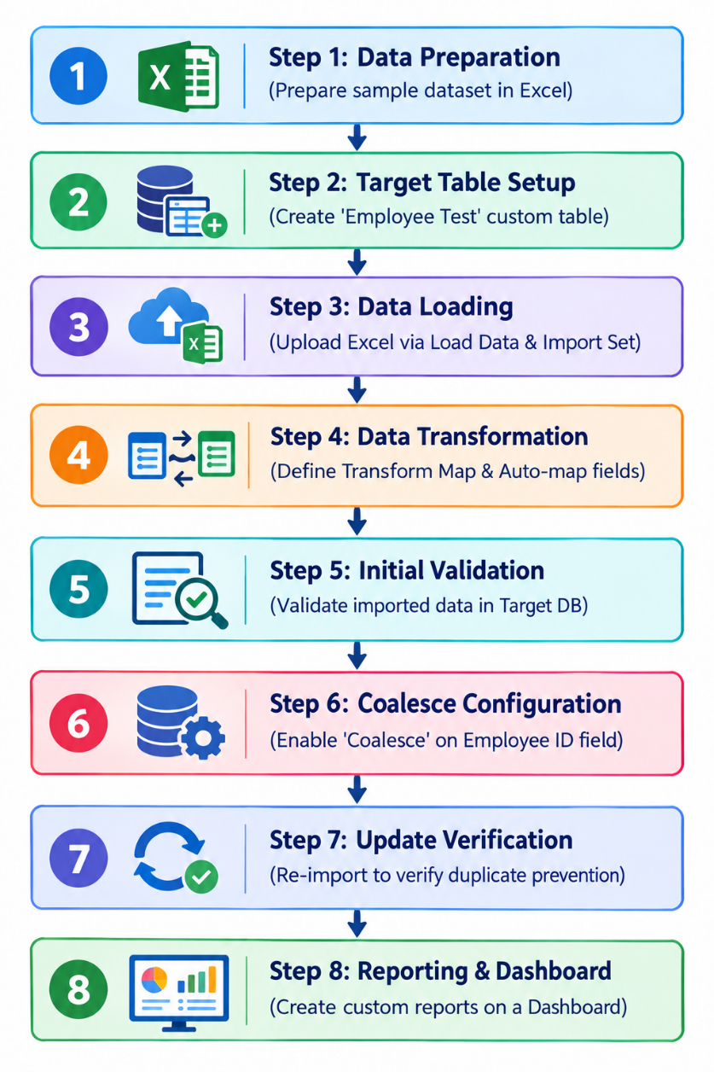

Screenshot:

